MEDITATION GUIDE APP
@CREATIVITY THINK (9483175986/7019689991)

ABSTRACT:
Meditation Guide App is a web application designed to promote mindfulness, wellness, and stress relief. Users can access guided meditation sessions, log daily practice, track progress through charts, and set goals or reminders. Administrators can manage meditation content, monitor user progress, and review analytics dashboards. The backend uses Django and Django Rest Framework for secure data handling, authentication, and business logic, while the frontend employs React, Recharts, and Axios to provide a responsive and interactive interface. The platform supports holistic wellness and efficient administrative oversight..

INTRODUCTION OF THE PROJECT:
With increasing stress and lifestyle pressures, guided meditation apps have become essential for mental well-being. Meditation Guide App provides a platform where users can browse meditation sessions, practice mindfulness, log daily activities, and visualize progress through charts. Administrators manage session content, monitor user engagement, and analyze usage data via dashboards. Using Django and Django Rest Framework for the backend and React with Recharts on the frontend, this application ensures a seamless, interactive, and data-driven meditation experience for users and administrators..

PROJECT OBJECTIVES:

• Provide guided meditation sessions for users
• Allow users to log daily meditation practice
• Visualize progress with interactive charts
• Enable goal setting and reminders for consistent practice
• Allow administrators to manage meditation content
• Track user engagement and review analytics
• Support wellness and stress-relief programs

PROBLEM OF THE STATEMENT:
Many users struggle to maintain consistent meditation practices due to lack of guidance, tracking, or personalized feedback. Meditation Guide App addresses this by offering guided sessions, daily logs, progress visualization, and reminders. Administrators face challenges in monitoring user engagement and updating content efficiently. This platform resolves these issues by providing a comprehensive web-based solution that supports both user wellness and administrative oversight, ensuring structured meditation guidance and data-driven management..

MOTIVATION OF THE PROJECT:
• Promote mental wellness and mindfulness
• Encourage consistent meditation practice
• Provide personalized progress tracking
• Enable administrators to manage content and user engagement
• Facilitate stress relief through structured guided sessions

BLOCK DAIGRAM OF PROJECT:

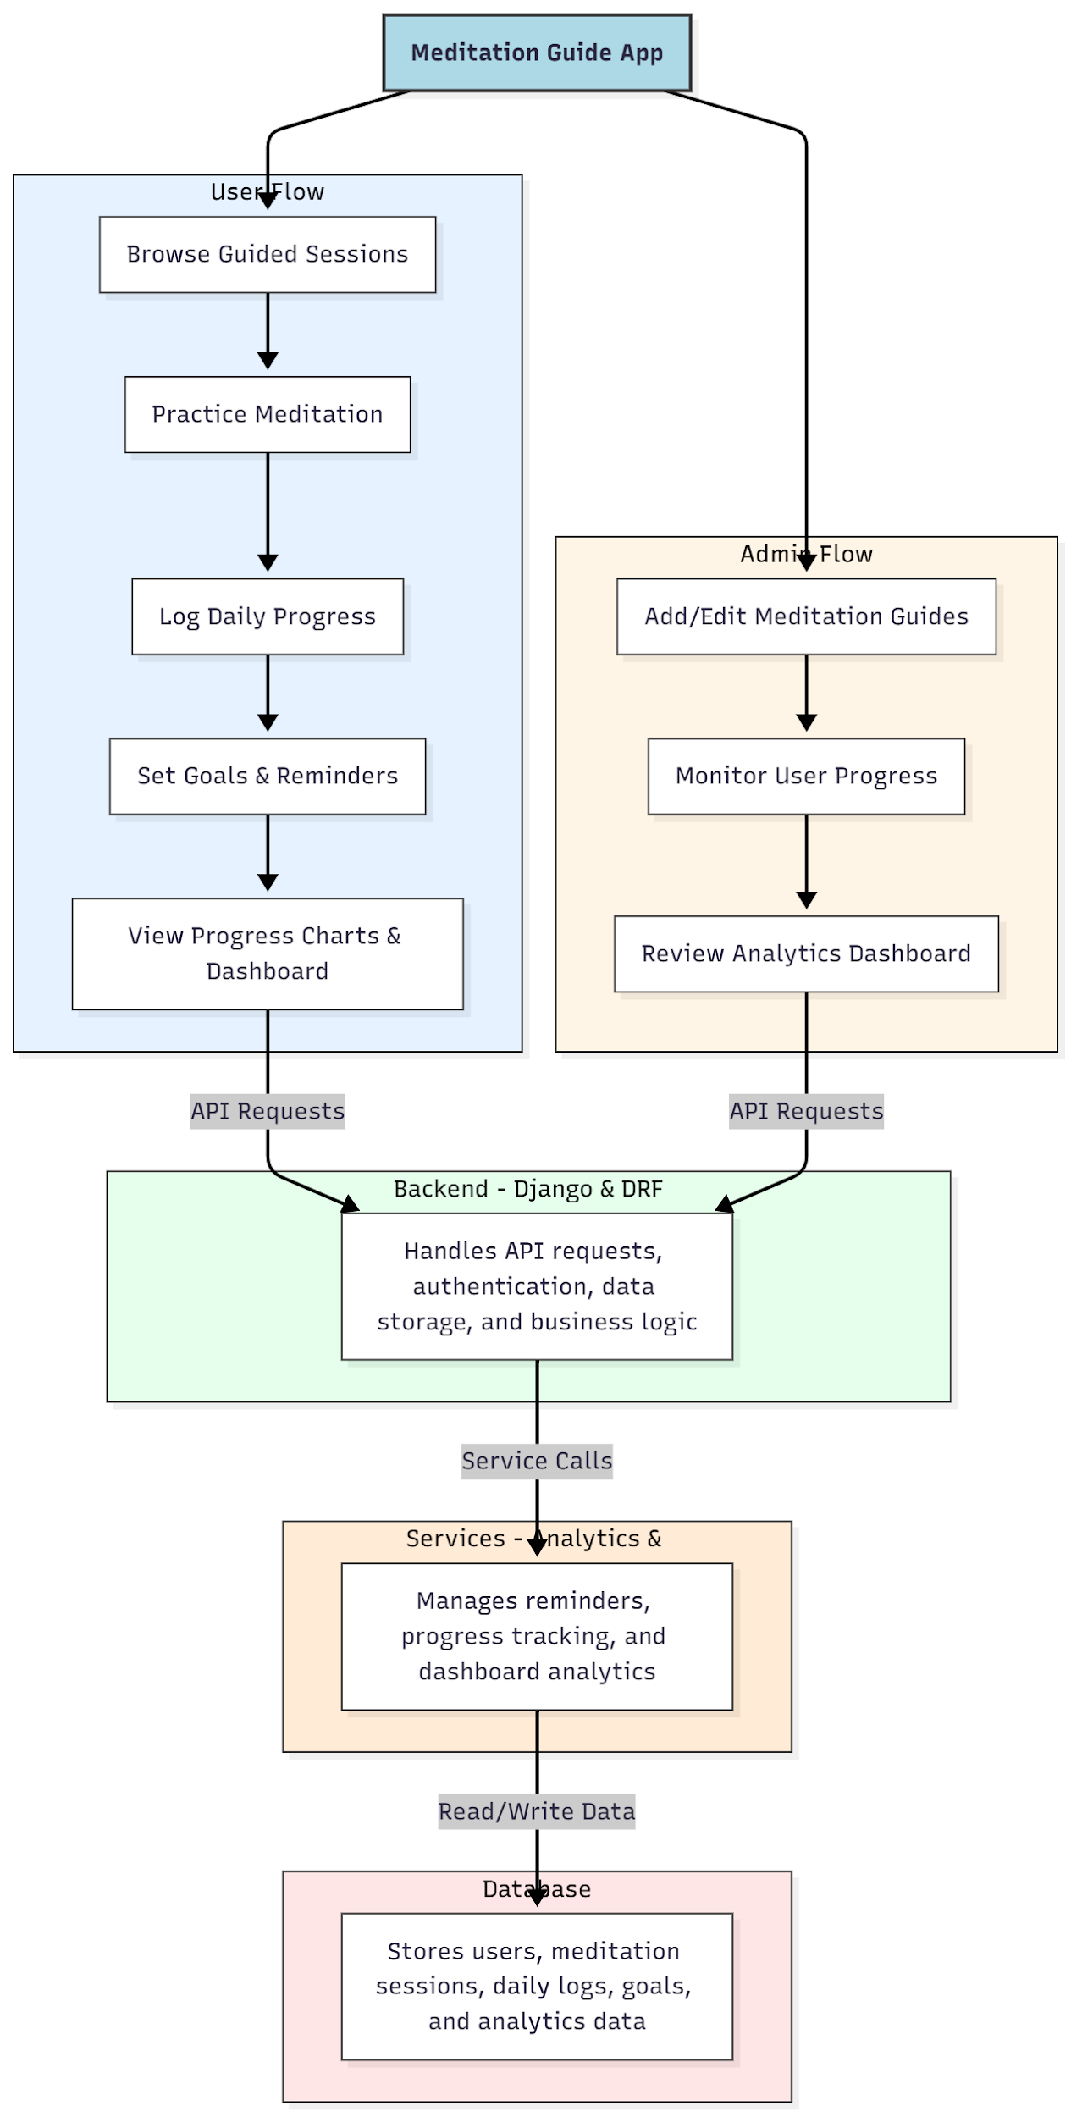

WORKING OF THE PROJECT:
Users browse guided meditation sessions, practice mindfulness exercises, log daily activities, set goals and reminders, and visualize progress on interactive dashboards. The backend processes API requests, manages authentication, stores session and user data, and executes business logic. Services handle reminders, progress tracking, and analytics updates. Administrators add or edit meditation guides, monitor user progress, and review analytics dashboards to ensure program effectiveness. The system provides structured guidance for users while maintaining administrative oversight..

SOFTWARE REQUIREMENT:
- Backend:
  - Python 3.x
  - Django
  - Django REST Framework
  - SQLite/PostgreSQL
- Frontend:
  - Node.js and npm
  - React.js
  - Axios
- Development Tools:
  - Visual Studio Code
  - Postman (for testing APIs)
  - Git/GitHub (for version control)
- Server/Deployment (Optional):
  - Gunicorn, Nginx, or Heroku/AWS for hosting

ADVANTAGES OF THE PROJECT:

• Structured guided meditation for users
• Daily log and progress tracking
• Goal setting and reminders for consistent practice
• Interactive dashboards for monitoring
• Administrative control over content and users
• Analytics-driven insight into user engagement
• Supports wellness and stress-relief initiatives
• Accessible and intuitive web platform

APPLICATIONS OF THE PROJECT:
• Wellness programs for individuals and organizations
• Meditation and mindfulness training
• Stress management and mental health initiatives
• Corporate wellness dashboards
• Educational programs on mindfulness
• Personal goal tracking for users
• Analytics-driven content management for admins
• Digital meditation guidance platforms

REFERENCES:

- Django REST Framework Documentation — Django Software Foundation. Django Documentation. Available: https://docs.djangoproject.com/
- Django REST Framework. DRF Documentation. Available: https://www.django-rest-framework.org/
- React. React Official Documentation. Available: https://reactjs.org/docs/getting-started.html
- Redux. Redux Documentation. Available: https://redux.js.org/introduction/getting-started
- PostgreSQL Global Development Group. PostgreSQL Documentation. Available: https://www.postgresql.org/docs/
- MySQL. MySQL Reference Manual. Available: https://dev.mysql.com/doc/
- Git. Git Documentation. Available: https://git-scm.com/doc
- Node.js. Node.js Documentation. Available: https://nodejs.org/en/docs/
- Axios. Axios Documentation. Available: https://axios-http.com/docs/intro
- Socket.io Documentation – https://socket.io/docs/

